Cognizant Technology Solution

Internship report
Submitted in Partial Fulfillment of the
Requirement for Final Year Project
Of

BACHELOR OF TECHNOLOGY
In
INFORMATION TECHNOLOGY

By
Khushal Rathod

(15007035)

Under the Guidance of

Mrs. Shilpa Mahajani
(industry supervisor)



DEPARTMENT INFORMATION TECHNOLOGY
GOVERNMENT COLLEGE OF ENGINEERING
AMRVATI, MAHARASHTRA(INDIA) -444604
Government College of Engineering, Amravati

CERTIFICATE

I hereby certify that the work which is being presented in the internship entitled “Cognizant Technology Solution” in partial fulfillment of the requirement for the award of degree of Bachelor of Technology and submitted in Department of Information Technology, Government College of Engineering, Amravati is an authentic record of my own work carried out during period of internship under the supervision of Akash Patni,Sr. Manager, Cognizant.

I have not submitted the matter presented in this internship anywhere for the award of any other degree or to any other institute.

Date: (Khushal Rathod)

This is to certify that the above statement made by the candidate is correct to best of my knowledge.

Date: (Akash Patni)

Sr. Manager & Supervisor

Date: (Shilpa Mahajani)
Industry Supervisor

Signature of Examiner

ACKNOWLEDGEMENT

The internship opportunity I had with Cognizant Technology Solutions Pvt. Ltd. was a great chance for learning and professional development. Therefore, I consider myself as a very lucky individual as I was provided with an opportunity to be a part of it. I am also grateful for having a chance to meet so many wonderful people and professionals who led me through this internship period.
I express my deepest thanks to Mrs. Shilpa Mahajani as Industry Supervisor for taking part in useful decision & giving necessary advices and guidance and arranged all facilities to make internship easier and successful. I choose this moment to acknowledge her contribution gratefully. It is my radiant sentiment to place on record my best regards, deepest sense of gratitude to Mr. Akash Patni, department Mentor, for his careful and precious guidance, which were extremely valuable for my study both theoretically and practically. I perceive as this opportunity as a big milestone in my career development. I will strive to use gained skills and knowledge in the best possible way, and I will continue to work on their improvement, in order to attain desired career objectives. Hope to continue cooperation with all of you in the future.

Sincerely,
Name: Khushal Rathod
Place: Pune, Hinjewadi
Date:

Declaration

I hereby declare that I have completed four months of my training at Cognizant Technology Solutions Pvt. Ltd, Hinjewadi, Pune from January 2019 to May 2019 under the guidance of Mr. Akash Patni. I have declared that I have worked with full dedication during these four months of training and my learning outcomes fulfill the requirements of training for the award of degree of Bachelor of Technology in Information Technology, Government College of Engineering, Amravati.

Khushal Rathod
Date: 29 April 2019 ID: 15007035

TABLE OF CONTENTS PAGE NO.
- Chapter 1: Company Profile…………………………………..……6
  - Introduction………………………………………………..……6
  - Business Model…………………………………………...…….7
- Chapter 2: Design Thinking………………………………...………8
  - The five stages of design thinking………………………..…….9
  - The origins of design thinking……………………….………...10
- Chapter 3: Agile SDLC……………………….……………………12
3.1 Agile manifesto principles…………………….………..………14
3.2 Agile vs. Traditional SDLC model…………….……….………14
3.3 Agile Ceremonies……………………………..………..………15
3.4 Agile Model- Pros and Cons…………………..………..………18
4. Chapter 4: Project Assigned- Customer Relationship Management..19
  - Overview………………………………………………………...19
  - Technology used………… …………………………………….22
  - Methodologies Used …………………………………………....27
  - Product Scope …………………………………………………..29
  - Definition ………………………………………………………30
  - E-R Diagram……………………………………………………31
  - Use Case Diagram……………………………………………...32
  - Snapshots……………………………………………………….33
- Chapter 5: Project Assigned- Python Scripting Demo …………….39
- References………………..…………………………………………41
Chapter 1: Company Profile
  - Introduction
Cognizant is an American multinational corporation that provides IT services, including digital, technology, consulting, and operations services. It is headquartered in Teaneck, New Jersey, United States of America. Cognizant is included in the NASDAQ-100 and the S&P 500 indices. It is also one of the fastest growing Fortune 500 companies. It was founded as an in-house technology unit of DUN & BRADSTREEIN in 1994, and started serving external clients in 1996.
Cognizant had a period of fast growth during the 2000s, becoming a Fortune 500 company in 2011. In 2015, the FORTUNE Magazine named it as the world's fourth most admired IT Services company. In 2017, Cognizant was named in Fortune’s Future 50 list.
Cognizant provides information technology, information security, consulting, ITO and BPO services. These include business & technology consulting, system integration, application development & maintenance, IT infrastructure services, analytics, business intelligence data, warehousing, customer relationship management, supply chain management, engineering & manufacturing solutions, enterprise resource planning, research and development, outsourcing, and testing solutions.
Cognizant has three key practice areas that span its business — Digital Business, Digital Operations, and Digital Systems & Technology.
The company is split into two new major services, Nelson Media Research, and IMS Health. After some time, it became the public subsidiary of the IMS Health. But in 2003, Cognizant sold all its shares in the subsidiary and the CEO also resigned from his post. The company expanded its work from IT services to Outsourcing and business consulting as well. There was a fast growth in the success of Cognizant. The services provided include application development, business intelligence, supply chain management, CRM, etc.
Cognizant also follows a global model for delivery. There are many offshore offices of the companies span over many countries in the world. The main sources of business for the company were the American as well as European clients. The company is a provider of high-end services in all fields. It is one of the top 10 companies that are legitimate in bringing the employee on H-1B into the US.
The company also has plans to increase its US business operations in the coming years. A total of 50 recruiters is continually hiring in the United States for different positions in the US itself. The company has nine delivery centres in the United States, Bridgewater, New Jersey; Phoenix, Arizona, Des Moines Iowa, etc.
Cognizant houses around 150,000 employees and has spanned all over the world. There are many development centres of the company as well. There are many units which are divided into vertical and horizontal sections. The vertical unit is for Healthcare, Retail, Banking Services, whereas the horizontal unit focuses on mobile computing, testing, and BPO. More than 100,000 employees work in India. The major revenue of the company is from financial companies and then from healthcare industries.
The company also launched the Go Green initiative in the year 2008. This cause completely focused on recycling, waste management, and energy conservation. Cognizant is the 50th traded companies in the United States.

1.2 Business Model:

Like many other IT services firms, Cognizant follows a global delivery model based on offshore software R&D offshore outsourcing. The company has a number of offshore development centres outside the United States and near-shore centres in the U.S., Europe and South America.
In its early years, Cognizant gained business from a number of American and European companies with the help of the Dun & Bradstreet brand. The company's senior executives envisaged the firm as a provider of high-end customer services on-par with the six contemporary major system integrators (Accenture, BearingPoint, Capgemini, E&Y, Deloitte and IBM), but at lower prices.
Cognizant was ranked at 195 in Fortune top 200 list of 2018. Cognizant's excellence and shift to digital marketing, digital platforms interests and expertise in nearly all the leading database, digital marketing and emerging technologies has fetched it an eminent position across the globe.

Chapter 2: Design Thinking

Introduction:
Design thinking is a non-linear, iterative process which seeks to understand users, challenge assumptions, redefine problems and create innovative solutions to prototype and test. The method consists of 5 phases—Empathize, Define, Ideate, Prototype and Test and is most useful when you want to tackle problems that are ill-defined or unknown.

Importance:
Over recent decades, it has become crucial to develop and refine skills which allow us to understand and act on rapid changes in our environment and behaviour. The world has become increasingly interconnected and complex, and design thinking offers a means to grapple with all this change in a more human-centric manner.
Design teams use design thinking to tackle ill-defined or unknown problems (otherwise known as wicked problems) because the process reframes these problems in human-centric ways, and allows designers to focus on what’s most important for users. Design thinking offers us a means to think outside the box and also dig that bit deeper into problem solving. It helps designers carry out the right kind of research, create prototypes and test out products and services to uncover new ways to meet users’ needs.
The design thinking process has become increasingly popular over the last few decades because it was key to the success of many high-profile, global organizations—companies such as Google, Apple and Airbnb have wielded it to notable effect, for example. This outside the box thinking is now taught at leading universities across the world and is encouraged at every level of business.
Design thinking improves the world around us every day because of its ability to generate ground-breaking solutions in a disruptive and innovative way. Design thinking is more than just a process, it opens up an entirely new way to think, and offers a collection of hands-on methods to help you apply this new mindset.

2.1 The Five Stages of Design Thinking:
The Hasso Plattner Institute of Design at Stanford, commonly known as the d.school, describes design thinking as a five-stage process. It’s important to note these stages are not always sequential and designers can often run the stages in parallel, out of order and repeat them in an iterative fashion.
The various stages of design thinking should be understood as different modes which contribute to the entire design project, rather than sequential steps. The ultimate goal throughout is to derive as deep an understanding of the product and its users as possible.
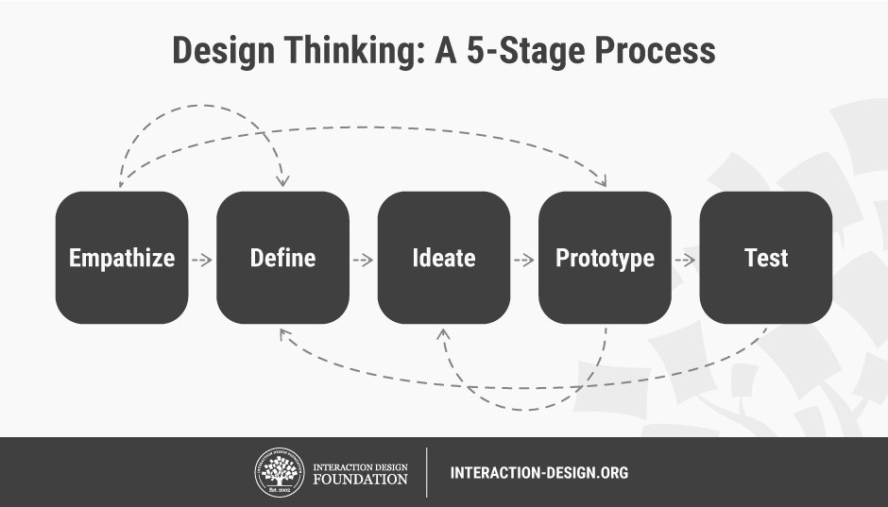

- Stage 1: Empathize—Research Your Users' Needs
The first stage of the design thinking process allows you to gain an empathetic understanding of the problem you’re trying to solve, typically through user research. Empathy is crucial to a human-centered design process like design thinking because it allows you to set aside your own assumptions about the world and gain real insight into users and their needs.
- Stage 2: Define—State Your Users' Needs and Problems
In the Define stage, you accumulate the information you created and gathered during the Empathize stage. You analyse your observations and synthesize them to define the core problems you and your team have identified so far. You should always seek to define the problem statement in a human-centred manner as you do this.
- Stage 3: Ideate—Challenge Assumptions and Create Ideas
Designers are ready to generate ideas as they reach the third stage of design thinking. The solid background of knowledge from the first two phases means you can start to “think outside the box”, look for alternative ways to view the problem and identify innovative solutions to the problem statement you’ve created.
- Stage 4: Prototype—Start to Create Solutions
This is an experimental phase, and the aim is to identify the best possible solution for each of the problems identified during the first three stages. Design teams will produce a number of inexpensive, scaled-down versions of the product (or specific features found within the product) to investigate the problem solutions generated in the previous stage.
- Stage 5: Test—Try Your Solutions Out
Designers or evaluators rigorously test the complete product using the best solutions identified in the Prototype phase. This is the final phase of the model but, in an iterative process such as design thinking, the results generated are often used to redefine one or more further problems. Designers can then choose to return to previous stages in the process to make further iterations, alterations and refinements to rule out alternative solutions.
2.2 The Origins of Design Thinking
Both the industrial revolution and World War II pushed the boundaries of what we thought was technologically possible. Engineers, architects and industrial designers—as well as cognitive scientists—then began to converge on the issues of collective problem solving, driven by the significant societal changes that took place at that time. Design thinking emerged, or should we say converged, out of the muddy waters of this chaos from the 50s and 60s onwards.
Cognitive scientist and Nobel Prize laureate Herbert A. Simon was the first to mention design thinking as a way of thinking in his 1969 book, The Sciences of the Artificial. He then went on to contribute many ideas throughout the 70s which are now regarded as principles of design thinking.
From the 1970s onwards, design thinking started to combine the human, technological and strategic needs of our times and progressively developed over the decades to become the leading innovation methodology it is today. Design thinking continues to gain ground across a wide range of industries and is still explored and enhanced by those at the forefront of the field.

Chapter 3: Agile SDLC

Introduction:
Agile SDLC model is a combination of iterative and incremental process models with focus on process adaptability and customer satisfaction by rapid delivery of working software product. Agile Methods break the product into small incremental builds. These builds are provided in iterations. Each iteration typically lasts from about one to three weeks. Every iteration involves cross functional teams working simultaneously on various areas like −
- Planning
- Requirements Analysis
- Design
- Coding
- Unit Testing and
- Acceptance Testing.
At the end of the iteration, a working product is displayed to the customer and important stakeholders.
Agile model believes that every project needs to be handled differently and the existing methods need to be tailored to best suit the project requirements. In Agile, the tasks are divided to time boxes (small time frames) to deliver specific features for a release.
Iterative approach is taken and working software build is delivered after each iteration. Each build is incremental in terms of features; the final build holds all the features required by the customer.

Here is a graphical illustration of the Agile Model –

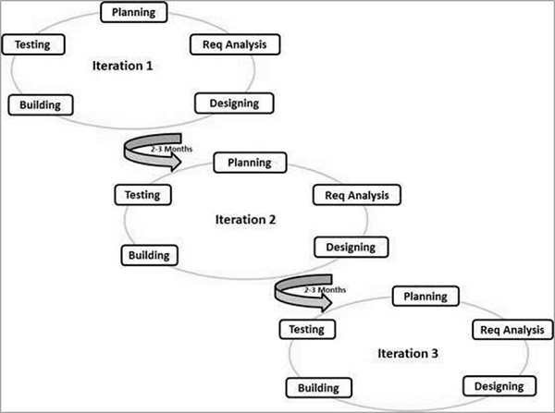

The Agile thought process had started early in the software development and started becoming popular with time due to its flexibility and adaptability.
The most popular Agile methods include Rational Unified Process (1994), Scrum (1995), Crystal Clear, Extreme Programming (1996), Adaptive Software Development, Feature Driven Development, and Dynamic Systems Development Method (DSDM) (1995). These are now collectively referred to as Agile Methodologies, after the Agile Manifesto was published in 2001.

3.1 Agile Manifesto principles –

- Individuals and interactions − In Agile development, self-organization and motivation are important, as are interactions like co-location and pair programming.
- Working software − Demo working software is considered the best means of communication with the customers to understand their requirements, instead of just depending on documentation.
- Customer collaboration − As the requirements cannot be gathered completely in the beginning of the project due to various factors, continuous customer interaction is very important to get proper product requirements.
- Responding to change − Agile Development is focused on quick responses to change and continuous development.

3.2 Agile Vs Traditional SDLC Models

Agile is based on the adaptive software development methods, whereas the traditional SDLC models like the waterfall model is based on a predictive approach. Predictive teams in the traditional SDLC models usually work with detailed planning and have a complete forecast of the exact tasks and features to be delivered in the next few months or during the product life cycle.
Predictive methods entirely depend on the requirement analysis and planning done in the beginning of cycle. Any changes to be incorporated go through a strict change control management and prioritization.
Agile uses an adaptive approach where there is no detailed planning and there is clarity on future tasks only in respect of what features need to be developed. There is feature driven development and the team adapts to the changing product requirements dynamically. The product is tested very frequently, through the release iterations, minimizing the risk of any major failures in future.
Customer Interaction is the backbone of this Agile methodology, and open communication with minimum documentation are the typical features of Agile development environment. The agile teams work in close collaboration with each other and are most often located in the same geographical location.

3.3 Agile Ceremonies–
Meetings, or "ceremonies" are an important part of agile development. But they are one of many important elements, and shouldn’t be conducted in a vacuum. (It's tempting to add some ceremonies to a waterfall project and call it "agile", but this will get you nowhere.)
Let's take a look at each of the agile ceremonies, and understand how they empower the team and drive agile development.
Note: A number of these ceremonies come from the practice of scrum which is an iterative, time-boxed approach to implementing agile. The concepts behind these ceremonies can be applied to other forms of agile like kanban or lean. "Sprint" is a scrum-specific term. Other forms of agile use the more generic term "iteration" to indicate a time-boxed period of development.
Sprint Planning-

Attendees: development team, scrum master, product owner
When: At the beginning of a sprint.
Duration: Usually an hour per week of iteration–e.g. a two-week sprint kicks off with a two-hour planning meeting.
Agile Framework: Scrum. (Kanban teams also plan, of course, but they are not on a fixed iteration schedule with formal sprint planning)
Purpose: Sprint planning sets up the entire team for success throughout the sprint. Coming into the meeting, the product owner will have a prioritized product backlog. They discuss each item with the development team, and the group collectively estimates the effort involved. The development team will then make a sprint forecast outlining how much work the team can complete from the product backlog. That body of work then becomes the sprint backlog.
PRO TIP:
Use the sprint planning meeting to flesh out intimate details of the work that needs to get done. Encourage team members to sketch out tasks for all stories, bugs, and tasks that come into the sprint. Foster discussions and gather consensus on the plan of action. Effective planning significantly increases the team's chances of success meeting the commitments of the sprint.

Daily Stand-up-

Attendees: development team, scrum master, product owner
When: Once per day, typically in the morning.
Duration: No more than 15 minutes. Don't book a conference room and conduct the stand-up sitting down. Standing up helps keep the meeting short!
Agile Framework: Scrum and Kanban.
Purpose: Stand-up is designed to quickly inform everyone of what's going on across the team. It's not a detailed status meeting. The tone should be light and fun, but informative. Have each team member answer the following questions:
- What did I complete yesterday?
- What will I work on today?
- Am I blocked by anything?
There's an implicit accountability in reporting what work you completed yesterday in front of your peers. No one wants to be the team member who is constantly doing the same thing and not making progress.
Iteration review-

Attendees:
Required: development team, scrum master, product owner
Optional: project stakeholders
When: At the end of a sprint or milestone.
Duration: 30-60 minutes.
Agile Framework: Scrum and Kanban. Like planning, review for kanban teams should be aligned with team milestones rather than on a fixed cadence.
Purpose: Iteration review is a time to showcase the work of the team. They can be in a casual format like "demo Fridays", or in a more formal meeting structure. This is the time for the team to celebrate their accomplishments, demonstrate work finished within the iteration, and get immediate feedback from project stakeholders. Remember, work should be fully demonstrable and meet the team's quality bar to be considered complete and ready to showcase in the review.
PRO TIP:
At Atlassian, we take a casual approach to sprint reviews and give them a celebratory feel. We gather around a team member's desk and watch them demo their new feature. It's not uncommon to hear clapping throughout the office!

Retrospective-

Attendees: development team, scrum master, product owner
When: At the end of an iteration.
Duration: 60 minutes.
Agile Framework: Scrum and Kanban. Scrum teams do sprint retrospective based on a fixed cadence. Kanban teams can benefit from occasional retrospectives, too.
Purpose: Agile is about getting rapid feedback to make the product and development culture better. Retrospectives help the team understand what worked well–and what didn't.
Retrospectives aren't just a time for complaints without action. Use retrospectives to find out what's working so the team can continue to focus on those areas. Also, find out what's not working and use the time to find creative solutions and develop an action plan. Continuous improvement is what sustains and drives development within an agile team, and retrospectives are a key part of that.

3.4 Agile Model - Pros and Cons

Agile methods are being widely accepted in the software world recently. However, this method may not always be suitable for all products. Here are some pros and cons of the Agile model.
The advantages of the Agile Model are as follows −
- Is a very realistic approach to software development.
- Promotes teamwork and cross training.
- Functionality can be developed rapidly and demonstrated.
- Resource requirements are minimum.
- Suitable for fixed or changing requirements
- Delivers early partial working solutions.
- Good model for environments that change steadily.
- Minimal rules, documentation easily employed.
- Enables concurrent development and delivery within an overall planned context.
- Little or no planning required.
- Easy to manage.
- Gives flexibility to developers.
The disadvantages of the Agile Model are as follows −
- Not suitable for handling complex dependencies.
- More risk of sustainability, maintainability and extensibility.
- An overall plan, an agile leader and agile PM practice is a must without which it will not work.
- Strict delivery management dictates the scope, functionality to be delivered, and adjustments to meet the deadlines.
- Depends heavily on customer interaction, so if customer is not clear, team can be driven in the wrong direction.

Chapter 4: Customer Relationship Management
4.1 Introduction
Purpose of this Project
CRM software is for Telecommunication Company. CRM software records customer contact information such as email, telephone, website social media profile, history of bills and more. It can also automatically pull in other information, such as recent news about the customer’s activity, and it can store details such as a client's personal preferences on communications.
CRM gives you information about invoices and order number of customers. Orders are filtered according to date and are shown in particular timeline. Support team can filter orders according to date or order numbers.
The CRM system organizes this information to give you a complete record of individuals and companies, so you can better understand your relationship over time.
CRM software improves customer relationship management by creating a 360° view of the customer, capturing their interactions with the business, and by surfacing the information needed to have better conversations with customers. CRM enables a business to deepen its relationships with customers, service users, colleagues, partners and suppliers. Forging good relationships and keeping track of prospects and customers is crucial for customer acquisition and retention, which is at the heart of a CRM’s function. You can see everything in one place — a simple, customizable dashboard that can tell you a customer’s previous history with you, the status of their orders, any outstanding customer service issues, and more.

The benefits of CRM are
1. Enhanced contact management
2. Cross-team collaboration
3. Heightened productivity
4. Empowered sales management
5. Accurate sales forecasting
6. Reliable reporting
7. Improved sales metrics
8. Increased customer satisfaction and retention
9. Boosted marketing ROI
10. Enriched products and services
Purpose of CRM on Practice
- Guiding any kind of interplay and/or cooperation with clients;
- Acquiring new clients;
- Servicing current client base;
- Keeping clients;
- Identification of high-rated clients against the low-rated ones;
- Information update along with technical assistance on web resources 24/7;
- Following an individual approach to each client;
- Providing an effective mechanism to guide and schedule follow-up sales;
- Tracking all contact points between a company and a client;
- Identifying possible problems at early stages;
- Providing an effective mechanism to deal with client complaints;
- Tracking individual preferences through Internet activity;
- Personalizing product offerings to each client.
Objective
The major objective of this project is to ease customer details view for support team who are going to contact customers. It is intended to give 360-degree view of customer details.
Below are the objectives that shall be fulfilled post the execution of this project:

- Customer’s history 360-degree view.
- Requests for service by customer.
- Accepting requests made by customer and providing service.
- Customer timeline
- Order and Invoice Details
- Filter Details of customers

Scope
This sub-section shall state the scope of this detailed design document
- Create and maintain customer information.
Intended Audience
The intended audience for this document are
- Developers, testers, other associates in the project
- Technical lead, Scrum Master
- Product Owner
- Support Team
Business Case
With the rapid increase of customers in telecommunication companies a 360-degree view of customer’s history is very important to support team. While the importance of CRM has traditionally been as a sales and marketing tool, some of the biggest gains can come in other areas, such as customer services, HR, supply-chain and partner management.
4.2 Technologies Used
AngularJS
AngularJS is a structural framework for dynamic web apps. It lets you use HTML as your template language and lets you extend HTML's syntax to express your application's components clearly and succinctly. AngularJS's data binding and dependency injection eliminate much of the code you would otherwise have to write. And it all happens within the browser, making it an ideal partner with any server technology.
AngularJS is what HTML would have been, had it been designed for applications. HTML is a great declarative language for static documents. It does not contain much in the way of creating applications, and as a result building web applications is an exercise in what do I have to do to trick the browser into doing what I want?
The impedance mismatch between dynamic applications and static documents is often solved with:
- a library - a collection of functions which are useful when writing web apps. Your code is in charge and it calls into the library when it sees fit. E.g., jQuery.
- frameworks - a particular implementation of a web application, where your code fills in the details. The framework is in charge and it calls into your code when it needs something app specific. E.g., durandal, ember, etc.
AngularJS takes another approach. It attempts to minimize the impedance mismatch between document centric HTML and what an application needs by creating new HTML constructs. AngularJS teaches the browser new syntax through a construct we call directives. Examples include:
- Data binding, as in {{}}.
- DOM control structures for repeating, showing and hiding DOM fragments.
- Support for forms and form validation.
- Attaching new behavior to DOM elements, such as DOM event handling.
- Grouping of HTML into reusable components.
HTML
HTML is a computer language devised to allow website creation. These websites can then be viewed by anyone else connected to the Internet. It is relatively easy to learn, with the basics being accessible to most people in one sitting; and quite powerful in what it allows you to create. It is constantly undergoing revision and evolution to meet the demands and requirements of the growing Internet audience under the direction of the, the organization charged with designing and maintaining the language.
The definition of HTML is Hypertext Markup Language.
- Hypertext is the method by which you move around on the web — by clicking on special text called hyperlinks which bring you to the next page. The fact that it is hyper just means it is not linear — i.e. you can go to any place on the Internet whenever you want by clicking on links — there is no set order to do things in.
- Markup is what HTML tags do to the text inside them. They mark it as a certain type of text (italicised text, for example).
- HTML is a Language, as it has code-words and syntax like any other language.
Bootstrap
- Bootstrap is the most popular HTML, CSS and JavaScript framework for developing a responsive and mobile friendly website.
- It is absolutely free to download and use.
- It is a front-end framework used for easier and faster web development.
- It includes HTML and CSS based design templates for typography, forms, buttons, tables, navigation, modals, image carousels and many others.
- It can also use JavaScript plug-ins.
- It facilitates you to create responsive designs.
JSON
JSON is an open standard for exchanging data on the web. It supports data structures like object and array. So it is easy to write and read data from JSON.
What is JSON
- JSON stands for JavaScript Object Notation.
- JSON is an open standard data-interchange format.
- JSON is lightweight and self describing.
- JSON is originated from JavaScript.
- JSON is easy to read and write.
- JSON is language independent.
- JSON supports data structures such as array and objects.
JavaScript
JavaScript is a dynamic computer programming language. It is lightweight and most commonly used as a part of web pages, whose implementations allow client-side script to interact with the user and make dynamic pages. It is an interpreted programming language with object-oriented capabilities.
JavaScript was first known as LiveScript, but Netscape changed its name to JavaScript, possibly because of the excitement being generated by Java. JavaScript made its first appearance in Netscape 2.0 in 1995 with the name LiveScript. The general-purpose core of the language has been embedded in Netscape, Internet Explorer, and other web browsers.
The ECMA-262 Specification defined a standard version of the core JavaScript language.
- JavaScript is a lightweight, interpreted programming language.
- Designed for creating network-centric applications.
- Complementary to and integrated with Java.
- Complementary to and integrated with HTML.
- Open and cross-platform
CSS
Cascading Style Sheets, fondly referred to as CSS, is a simple design language intended to simplify the process of making web pages presentable.
CSS handles the look and feel part of a web page. Using CSS, you can control the color of the text, the style of fonts, the spacing between paragraphs, how columns are sized and laid out, what background images or colors are used, layout designs,variations in display for different devices and screen sizes as well as a variety of other effects.
CSS is easy to learn and understand but it provides powerful control over the presentation of an HTML document. Most commonly, CSS is combined with the markup languages HTML or XHTML.
Advantages of CSS
- CSS saves time − You can write CSS once and then reuse same sheet in multiple HTML pages. You can define a style for each HTML element and apply it to as many Web pages as you want.
- Pages load faster − If you are using CSS, you do not need to write HTML tag attributes every time. Just write one CSS rule of a tag and apply it to all the occurrences of that tag. So less code means faster download times.
- Easy maintenance − To make a global change, simply change the style, and all elements in all the web pages will be updated automatically.
- Superior styles to HTML − CSS has a much wider array of attributes than HTML, so you can give a far better look to your HTML page in comparison to HTML attributes.
- Multiple Device Compatibility − Style sheets allow content to be optimized for more than one type of device. By using the same HTML document, different versions of a website can be presented for handheld devices such as PDAs and cell phones or for printing.

4.3 Methodologies Used
SCRUM
Scrum is a framework within which people can address complex adaptive problems, while productively and creatively delivering products of the highest possible value.
Scrum itself is a simple framework for effective team collaboration on complex products. Scrum co-creators Ken Schwaber and Jeff Sutherland have written The Scrum Guide to explain Scrum clearly and succinctly. This Guide contains the definition of Scrum. This definition consists of Scrum’s roles, events, artifacts, and the rules that bind them together.
Scrum is:
- Lightweight
- Simple to understand
- Difficult to master
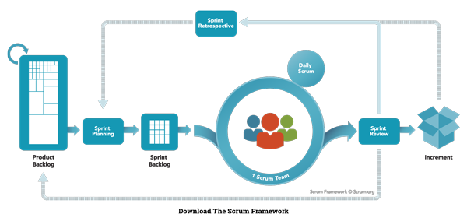
Scrum has three roles: Product Owner, Scrum Master, and Team.
Product Owner: The Product Owner should be a person with vision, authority, and availability. The Product Owner is responsible for continuously communicating the vision and priorities to the development team.It’s sometimes hard for Product Owners to strike the right balance of involvement. Because Scrum values self-organization among teams, a Product Owner must fight the urge to micro-manage. At the same time, Product Owners must be available to answer questions from the team.
Scrum Master: The Scrum Master acts as a facilitator for the Product Owner and the team. The Scrum Master does not manage the team. The Scrum Master works to remove any impediments that are obstructing the team from achieving its sprint goals. This helps the team remain creative and productive while making sure its successes are visible to the Product Owner. The Scrum Master also works to advise the Product Owner about how to maximize ROI for the team.
Team: According to Scrum’s founder, “the team is utterly self-managing.” The development team is responsible for self organizing to complete work. A Scrum development team contains about seven fully dedicated members (officially 3-9), ideally in one team room protected from outside distractions. For software projects, a typical team includes a mix of software engineers, architects, programmers, analysts, QA experts, testers, and UI designers. Each sprint, the team is responsible for determining how it will accomplish the work to be completed. The team has autonomy and responsibility to meet the goals of the sprint.

4.4 Product Scope
This product is a powerful web application for 360-degree view of customer’s history. CRM or customer relationship management, is concerned with the development and maintenance of mutually beneficial relationships with strategically significant partners. Its focus is the creation of long-term value, and not just short-term profits, for the company and all it works with. The scope of CRM can thus be defined according to its constituencies, how long-term value can be created for and with them and the benefits of doing so.

The Customer
The customer is of key importance because only relationships with customers generate revenues for a company. Establishing a good long-term relationship with customers can take the form of the provision of benefits such as special prices and preferential treatment. Doing so can bring about drastic increases in value due to frequent sales from satisfied customers, positive word of mouth, a reduced need for product sampling and advertising, and increased possibility of cross-selling or purchasing of other products.

The Suppliers
Suppliers provide input, such as raw materials, technologies, components, investment, human resources and expertise, to the company’s value chain. In 2010 companies have tended to shift to a smaller number of suppliers and create and maintain long-term relationships with them. Enhanced performance can result from improved communication and coordination with this set of suppliers. Purchasing costs can be reduced thanks to elimination of the need to constantly seek cheaper sources. With fewer vendors, increased cooperation between the remaining parties in the form of management-information system alignment and customer-information sharing becomes possible.
4.5. Definition
- Client: Cognizant Client who is using our software.
- Customer: Cognizant Client’s end-customers. The companies that actually make Payments to Clients.
- Mechanic: They are project used words who will provide service to the customer.
- Invoice: A receipt of acknowledgement for the goods or services provided and their respective cost. Customer receives an invoice from the mechanic specifying the goods dispatched or soled and the cost associated with the purchase.
- Location Based: The customer will search for the mechanic on the closest vicinity.
- Rating: The customer will give the rating to the mechanic on the basis of the service provided by the mechanic.
- Notification: The customer will receive a notification on the basis of the mechanic acceptation or rejection.
- Payment: Money paid by Customer to Mechanic for some product or service they bought and got billed for. Payment can be in the form of: Checks, Cash or Credit or Debit Card transactions.

4.6 E-R Diagram
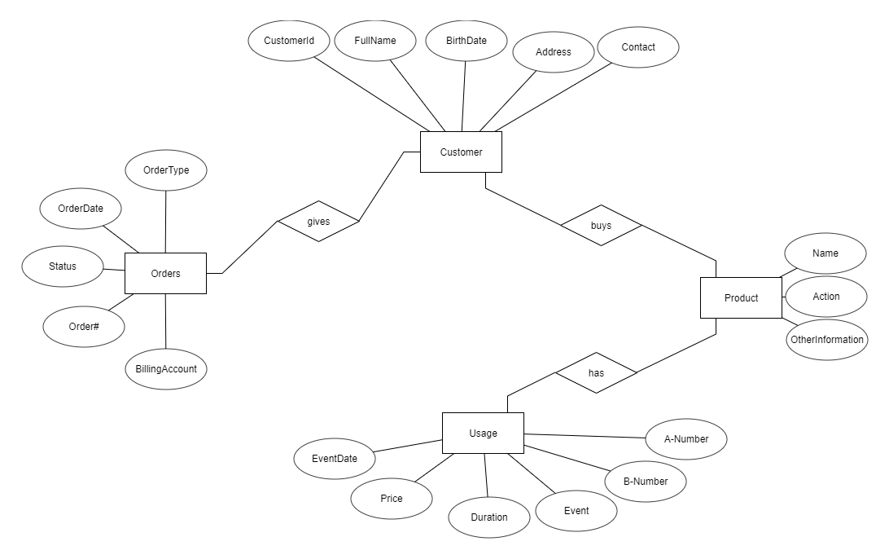

4.7 Use Case Diagram
Use Case Diagram of CRM Application System

Manage User and Full Application
Manage Customer Feedback
Create Customer Relationship
Check Requests or Raise Requests

Manage Products
Manage Offerings
Add Comments

Customer
Company

4.8 Snapshots
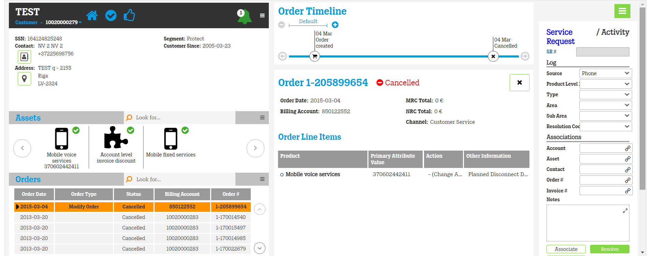

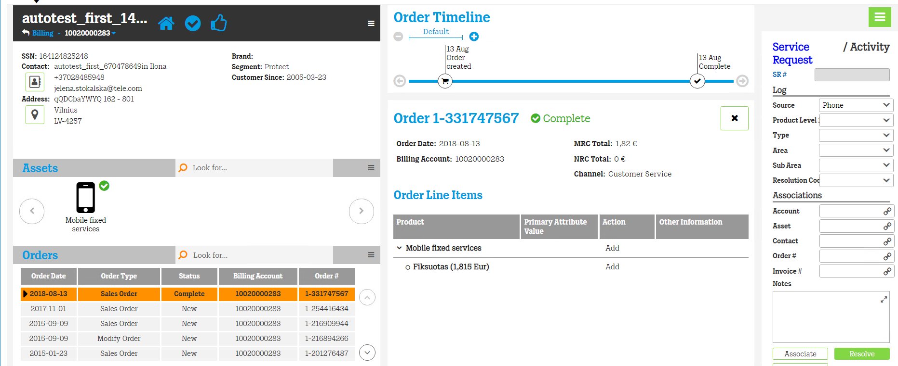
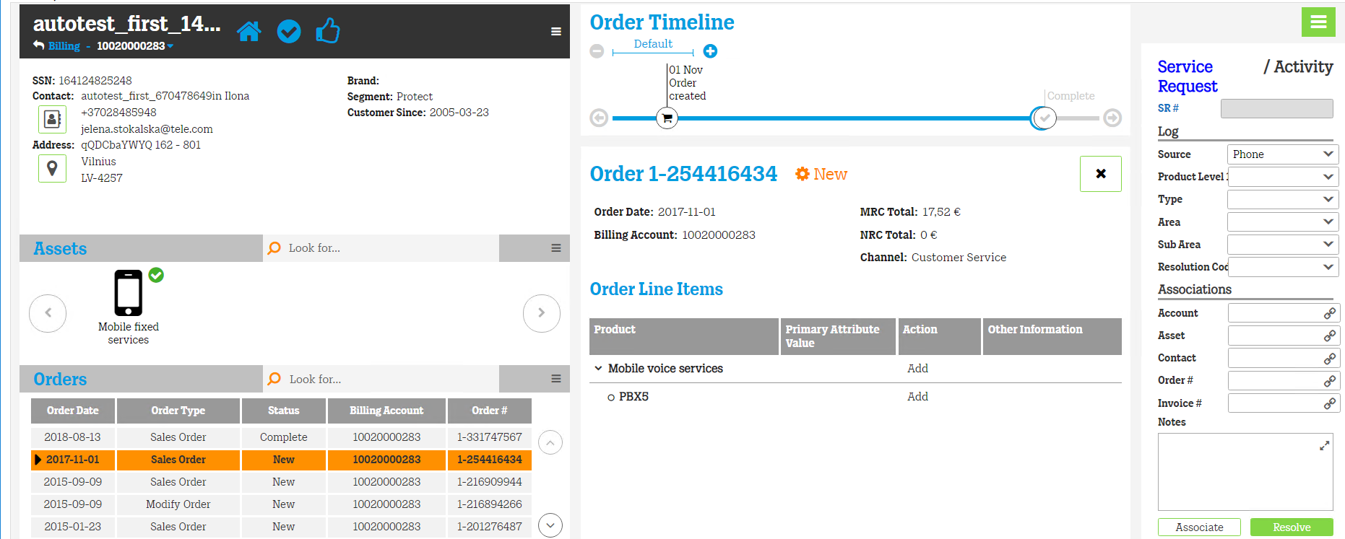

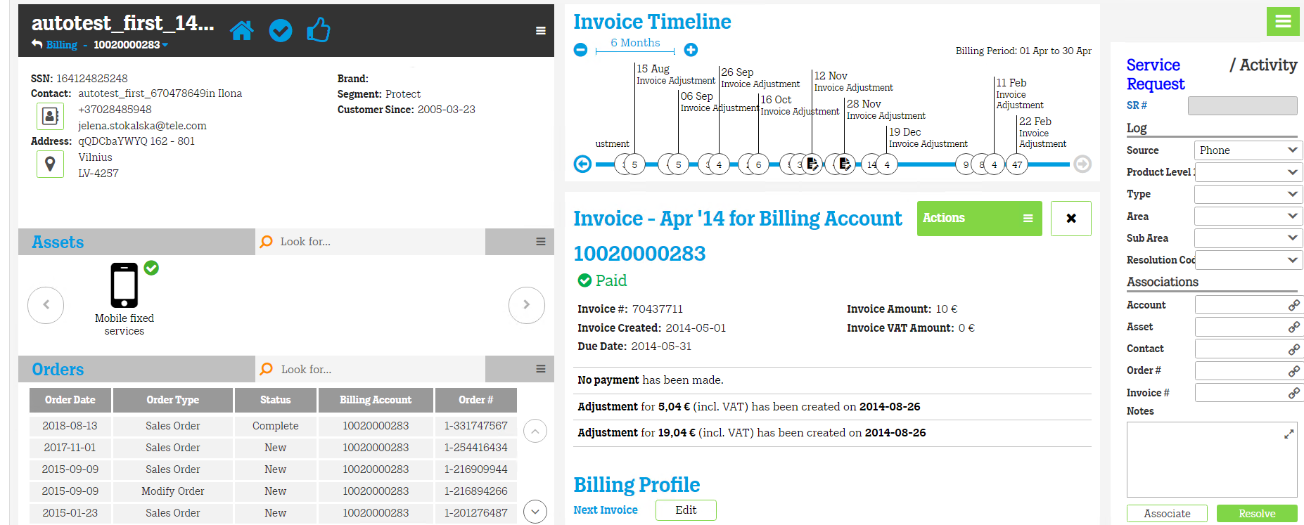
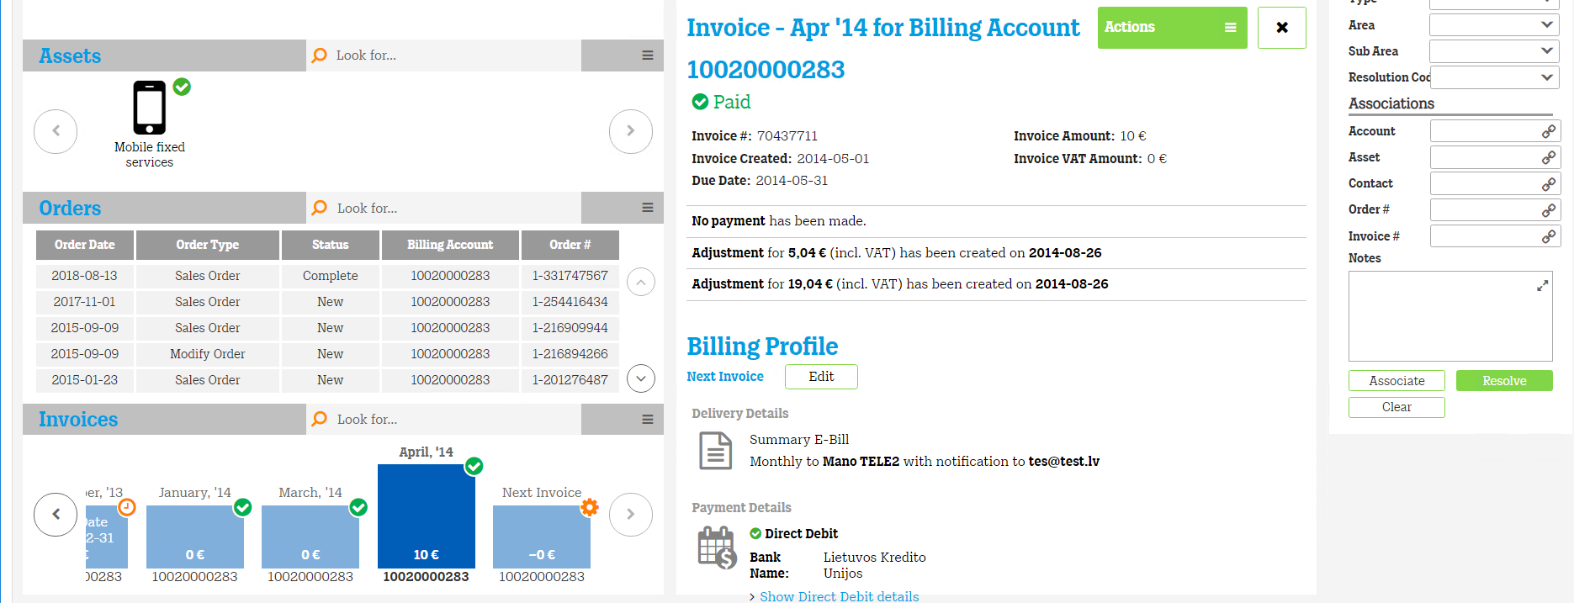

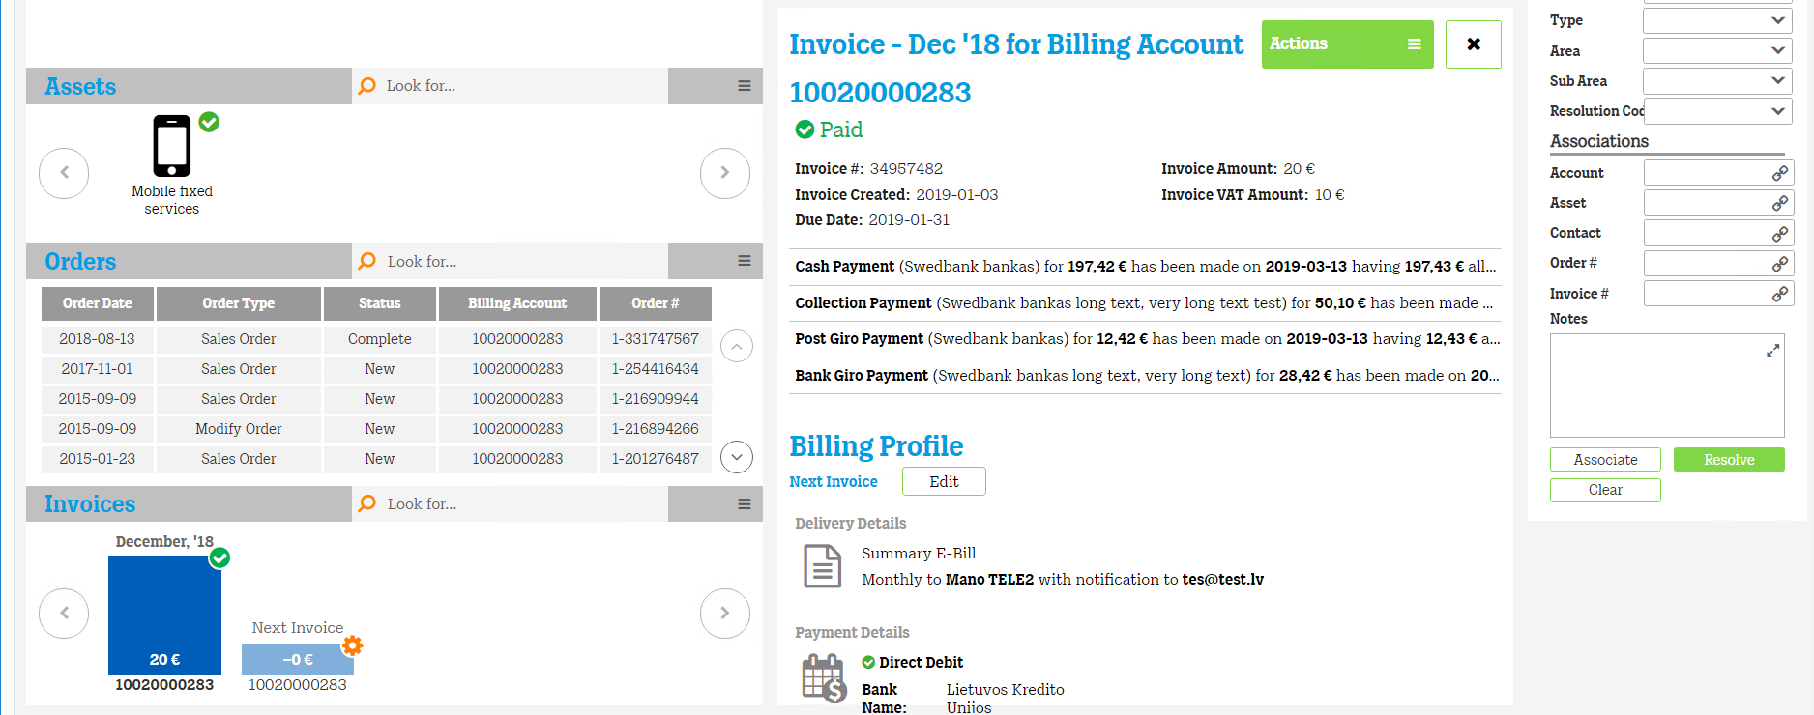
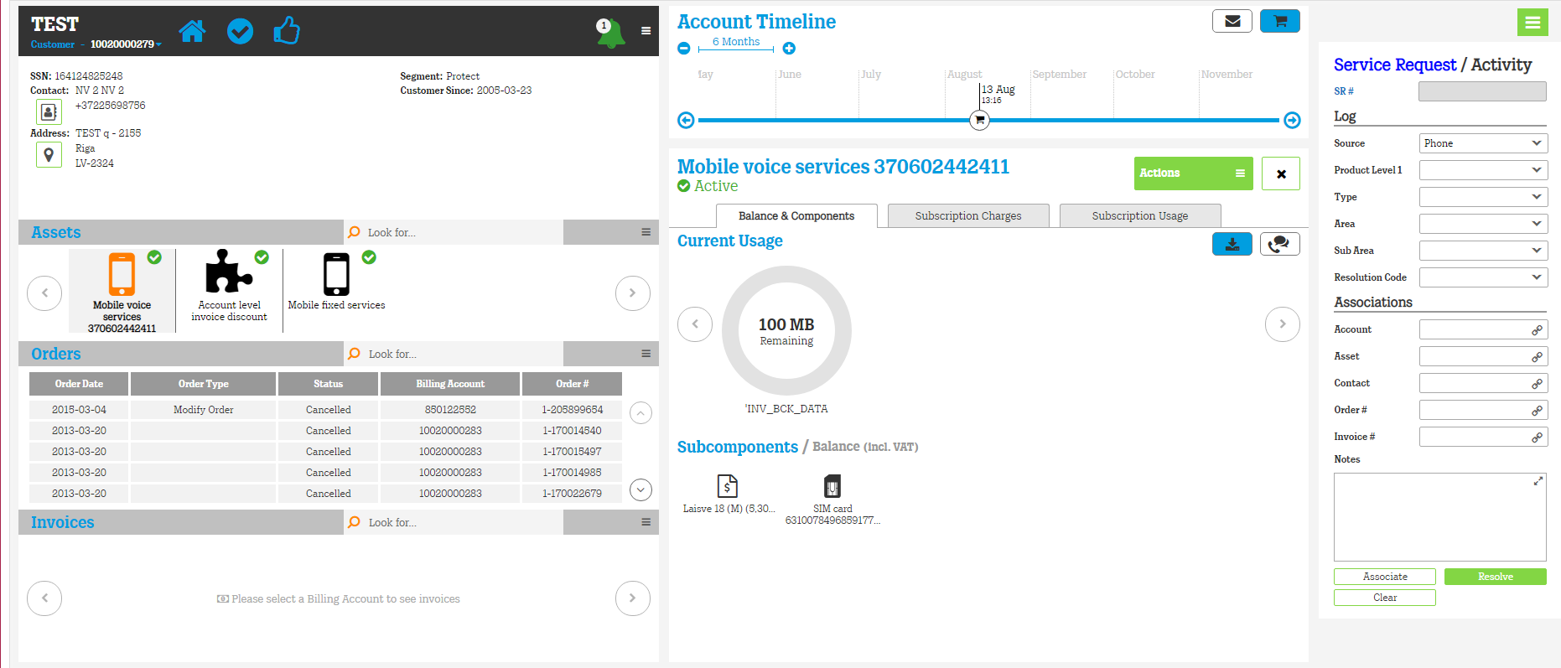

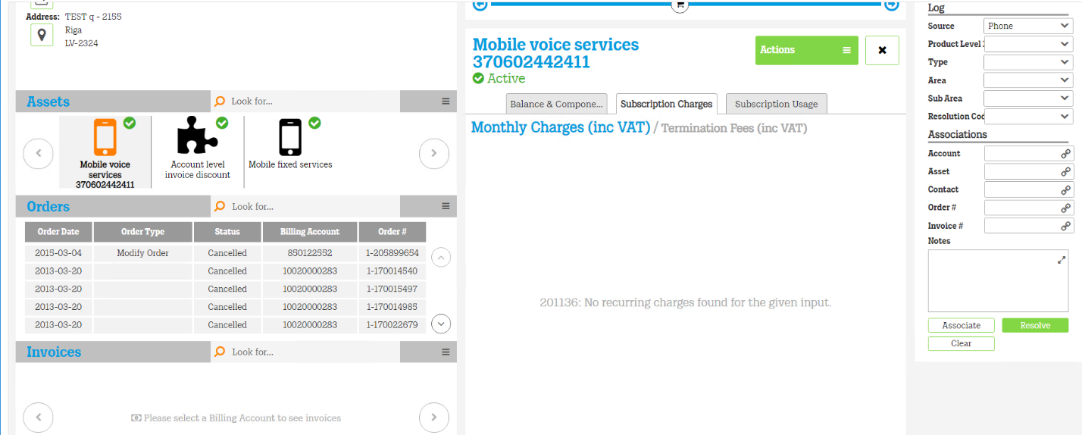

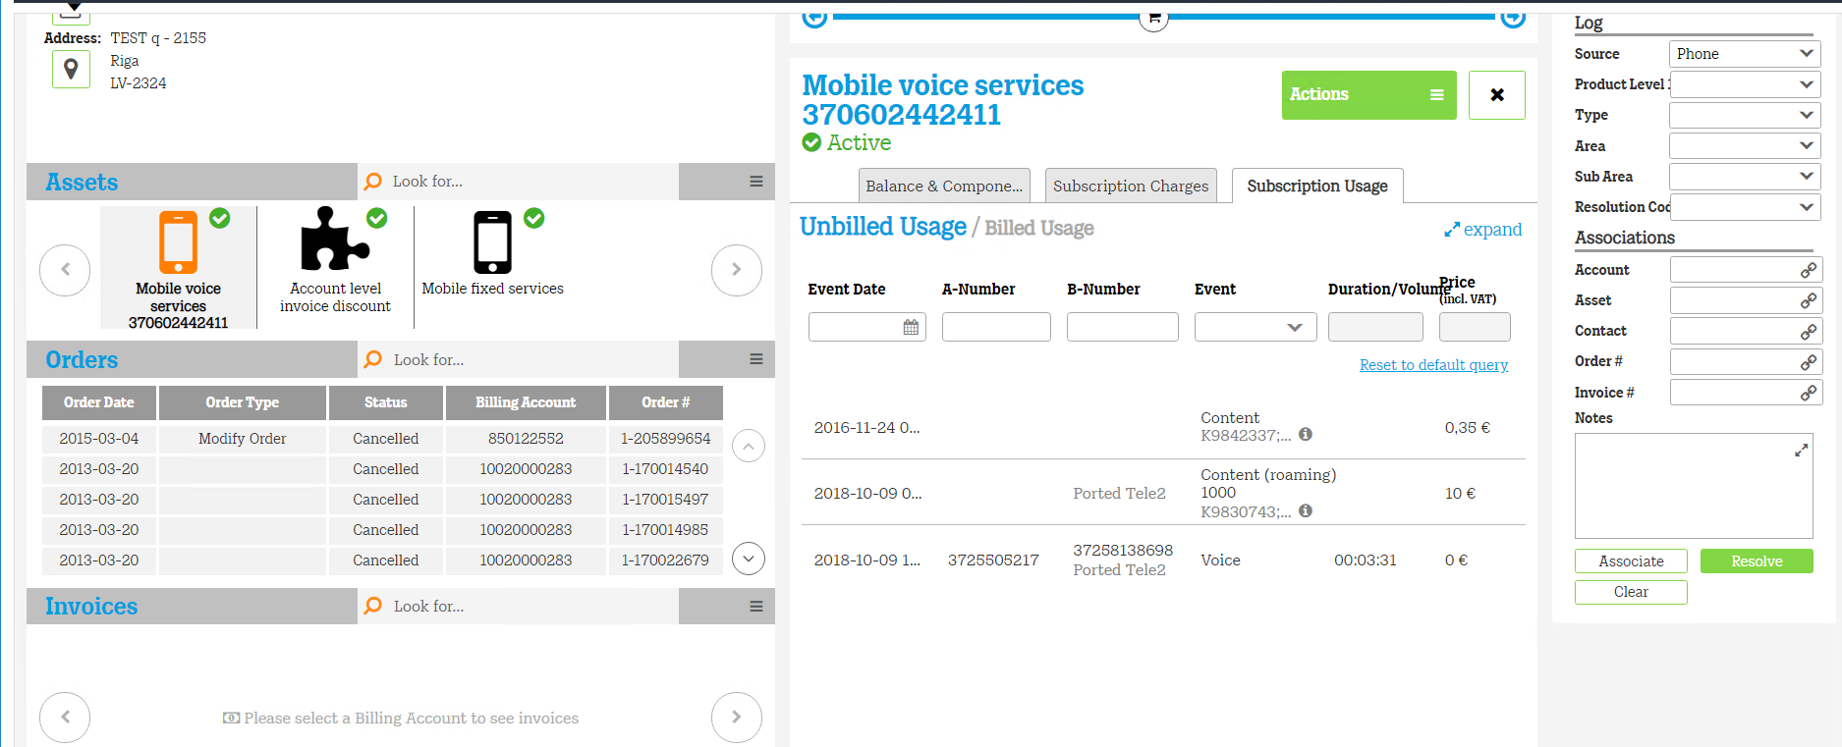

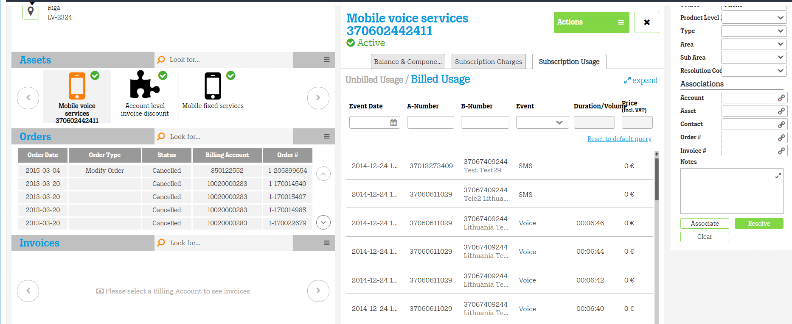
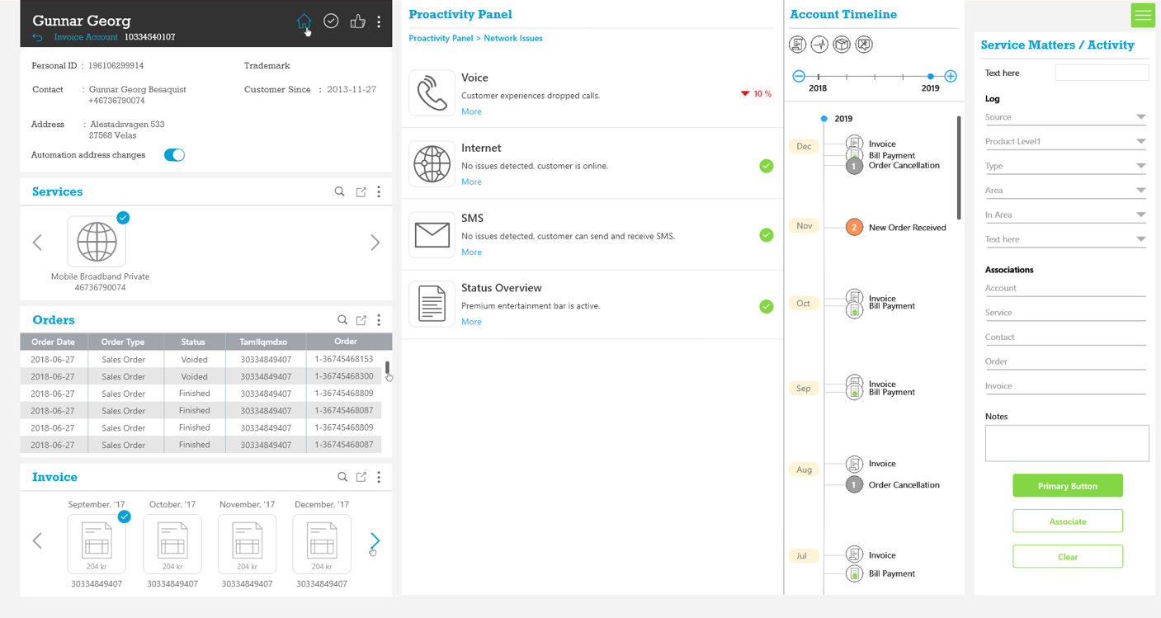

Chapter 5: Python Scripting
5.1 Introduction:
Scripting:
A script is used to automate certain tasks in a program. It can run by itself and it is less code intensive whereas modules in python is referred as a library, which cannot run, by its own. It needs to be imported in order to use it.
The benefits of Scripting are:
- Easy to learn and use
- Minimum programming knowledge and experience required
- Allow complex task to be performed in relatively few steps
- Allow simple creation and editing in a variety of text editors
- Allow the addition of dynamic and interactive activities to web pages
- Editing and running code is fast.

5.2. Technologies Used
5.2.1 Python
Python is an easy to learn, powerful programming language. It has efficient high-level data structures and a simple but effective approach to object-oriented programming. Python's elegant syntax and dynamic typing, together with its interpreted nature, make it an ideal language for scripting and rapid application development in many areas on most platforms.
Python uses an interpreter to translate and run its code and that's why it's called
a scripting language. A Python script normally can be full of functions that can
be imported as a library of functions in other scripts, or a python script can be a
Command that runs in Rhino.
5.2.2 MySQL
MySQL is the most popular Open Source Relational SQL Database Management System. MySQL is one of the best RDBMS being used for developing various web-based software applications. MySQL is developed, marketed and supported by MySQL AB, which is a Swedish company. This tutorial will give you a quick start to MySQL and make you comfortable with MySQL programming.

5.3 Data:
XML File:
- XML stands for extensible Markup Language.
- XML was designed to store and transport data.
- XML was designed to be both human- and machine-readable.
The data is provided in XML document
The script is going to collect the information from XML file as well as from the database of different customers and then compare both the values. If both the values are same the do nothing, simply forward the command and if the values and not same then execute the update command to update the value in database.
At the time of updating the value generate a log file which contains the old value and new value with time stamp using date time library in python.

Sample XML:
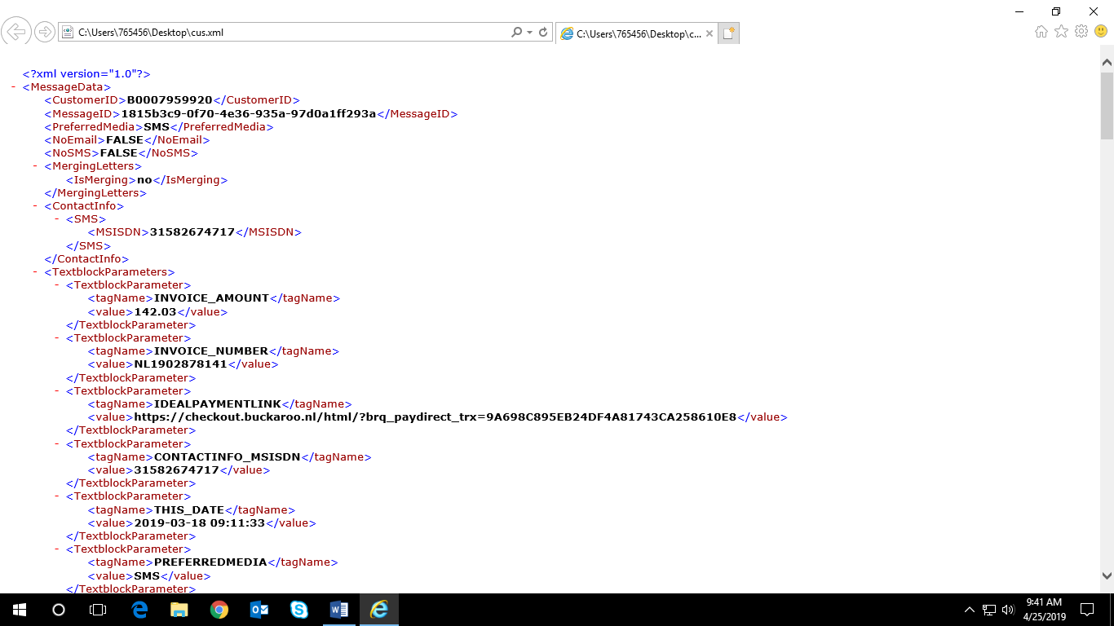

References:
https://www.geeksforgeeks.org/xml-parsing-python/
https://www.datacamp.com/community/tutorials/mysql-python
https://www.tutorialspoint.com/python3/
https://developer.mozilla.org/en-US/docs/Web/Guide/HTML/HTML5
https://www.tutorialspoint.com/css/css3_tutorial.htm
https://www.w3schools.com/angular/angular_intro.asp
https://getbootstrap.com/docs/4.3/getting-started/introduction/

